The Systematic Approach to the Design of Digital System

* Consider the digital system you are designing as composed of a Controller and a Processor.

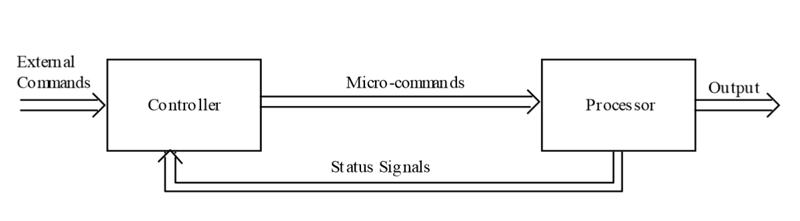

* Processor contains the regs, adders, counters, etc.
* Controller: a sequential machine which accepts Ext.Com and status signal.

: direct the operation of the processor.

* Design the system in 3 steps:

1. Decide the functions to be performed in the Processor and in the Controller.

Draw the diagram, indicate all Ext.C, micro-c, and status signals to be used.

1. Design the Processor utilizing those signals.

(draw out the logic diagram)

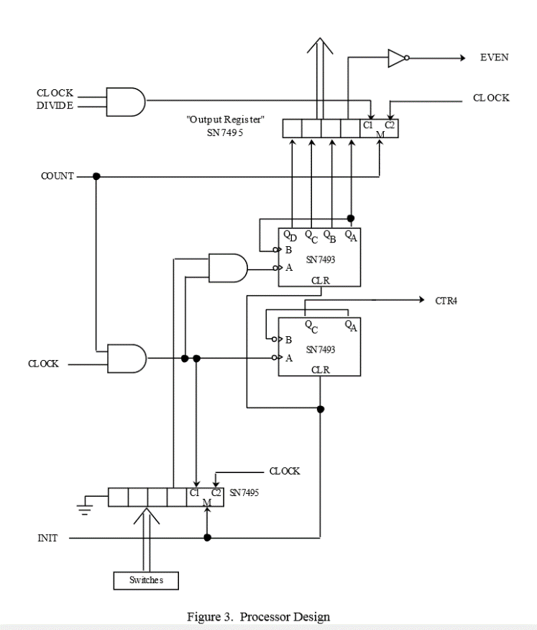

1. Design the Controller to generate the required sequences of micro-commands.

(controller state diagram, then find next-state function using k-map, then logic diagram)

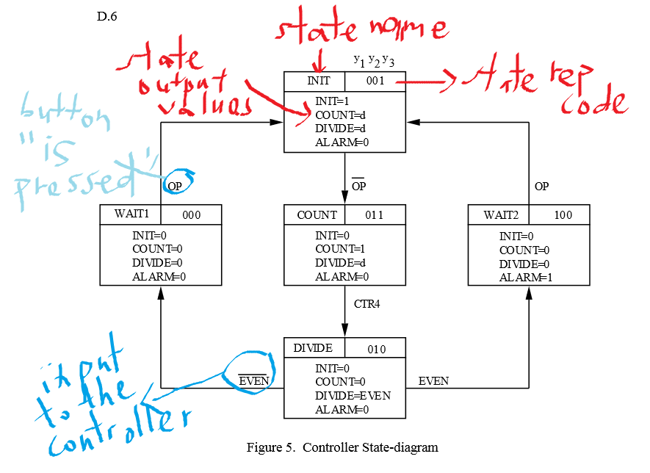

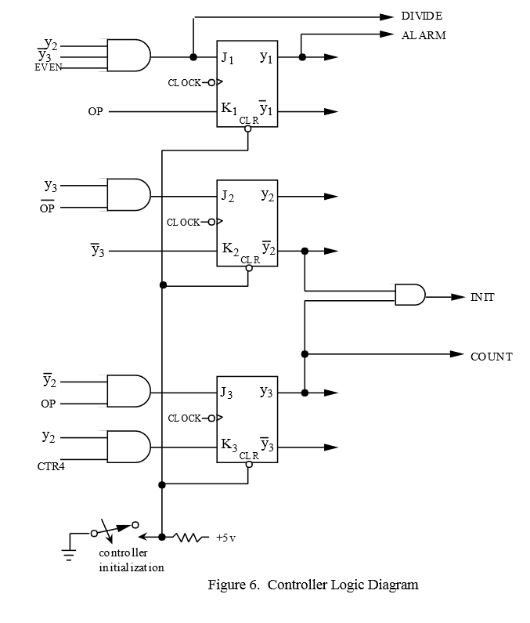

\*will require some backtrackings and modifications.

* An example of proposed configuration

